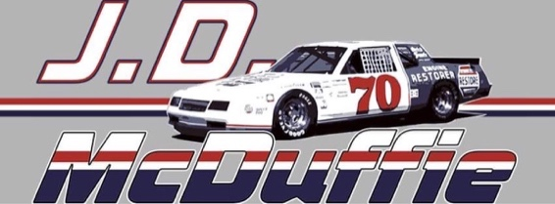

To Whom It May Concern,

I am writing this letter to highly recommend Adam Peele for any marketing and publicity positions within your organization. I have had the pleasure of working closely with Adam for several years, and his dedication, creativity, and commitment to excellence have truly impressed me.

Adam has played a vital role in supporting our racing family and the JD McDuffie NASCAR racing legend page. As our primary marketing and publicity consultant, he has demonstrated exceptional skills in developing and implementing effective strategies to enhance our brand presence. His expertise in social media management has significantly boosted our online engagement and visibility, enabling us to reach a wider audience of racing enthusiasts. Adam's ability to create engaging content and tailor it to various platforms has been instrumental in expanding our digital footprint.

Moreover, Adam has been instrumental in organizing and promoting events at Rockingham raceway, which have been crucial for keeping the spirit of racing alive. His meticulous attention to detail and strategic planning have ensured that each event is a resounding success, leaving a lasting impact on participants and attendees alike. His ability to coordinate with various stakeholders and manage event logistics has been invaluable.

One notable event where Adam's assistance truly shined was the mural festival in Sanford, North Carolina. His involvement in organizing and publicizing this event brought together artists, sponsors, and the local community to celebrate and showcase the vibrant art scene in our area. Adam's exceptional communication skills and collaborative approach fostered strong relationships with key individuals and organizations, creating a sense of unity and shared purpose throughout the festival.

Beyond his professional skills, Adam is a highly motivated and reliable individual. He consistently demonstrates a strong work ethic and a passion for delivering exceptional results. His ability to work both independently and as part of a team makes him an invaluable asset to any organization. Adam's positive attitude, adaptability, and willingness to go above and beyond expectations have earned him the respect and admiration of everyone he works with.

In conclusion, I wholeheartedly recommend Adam Peele for any marketing and publicity roles within your organization. His outstanding contributions to our racing family, the JD McDuffie NASCAR racing legend page, and the successful execution of various events speak volumes about his capabilities and dedication. I have no doubt that he will excel in any position he undertakes and will be a valuable asset to your team.

Please feel free to reach out to me if you require any further information or have any questions regarding Adam's qualifications. Thank you for considering his application.

Sincerely,

Wendy McDuffie
Vice President J.D. McDuffie Racing

