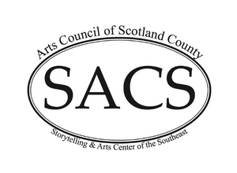
Storytelling Arts Center of the Southeast
131 S Main St
Laurinburg, NC 28352

February 27, 2023
To Whom it May Concern:
I’m writing this letter to support and to recommend Adam Peele. As chairman of the Board of Directors of the Storytelling Arts Center of the Southeast (SACS), I have worked with Adam for two years as he has provided public relations and media services for the organization.
Adam is personable and polite in dealing with multiple requests. He has been reliable and dependable in providing services for SACS and has shown that he is a team player. He has volunteered for additional tasks and has shown initiative in planning and carrying out events for SACS. He has willingly shared his expertise and thereby has educated directors on media aspects. Likewise, I think he has shown growth in interacting with diverse personal and their differing work styles and requests.
Adam has shown a passion for public relations and has put that passion into practice for our organization. SACS has benefited greatly from his efforts. I believe Adam would be a valuable asset and great team member to any organization.

Sincerely,
Dora Sharber
Dora Sharber
Storytelling Arts Center of the Southeast Chair

